UI-View 32

Filtering Stations from the Internet to RF

These setting assume that you have a working connection to the internet and have a working connection to your TNC.

1) From Main Map Screen on UI-View, go to File and Select “Edit IGATE.INI”

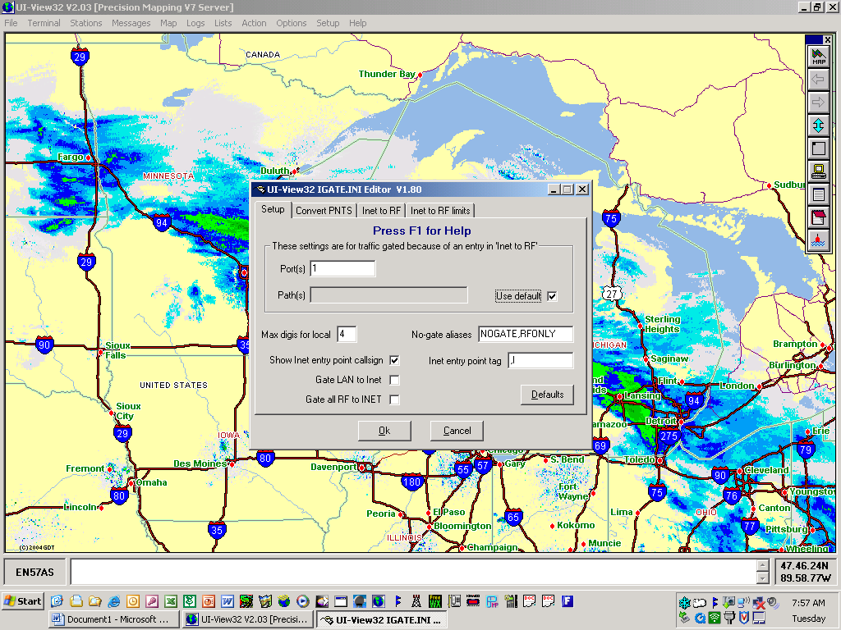

2) Setup Tab:
“Port(s)” is your RF port (usually Port 1) and Either Check the “Use Default” Box or put in your own path in the “Path(s)” box;
“Max Digis for local” is the number of digis that will be considered Local (Help File explains it);
“Show Inet entry point Callsign” needs to be checked because legally your station is TX’ing and needs to ID (When your station sends out its Own ID your callsign is in the packet path and it also shows how the packet got to RF);
“Nogate Aliases” should be NOGATE, RFONLY;
“Inet entry point tag” should be ,I
“Gate LAN to INET” is unchecked (See Help Files)
“Gate RF to INET” is unchecked (See Help Files)

3) Convert PNTS Tab:

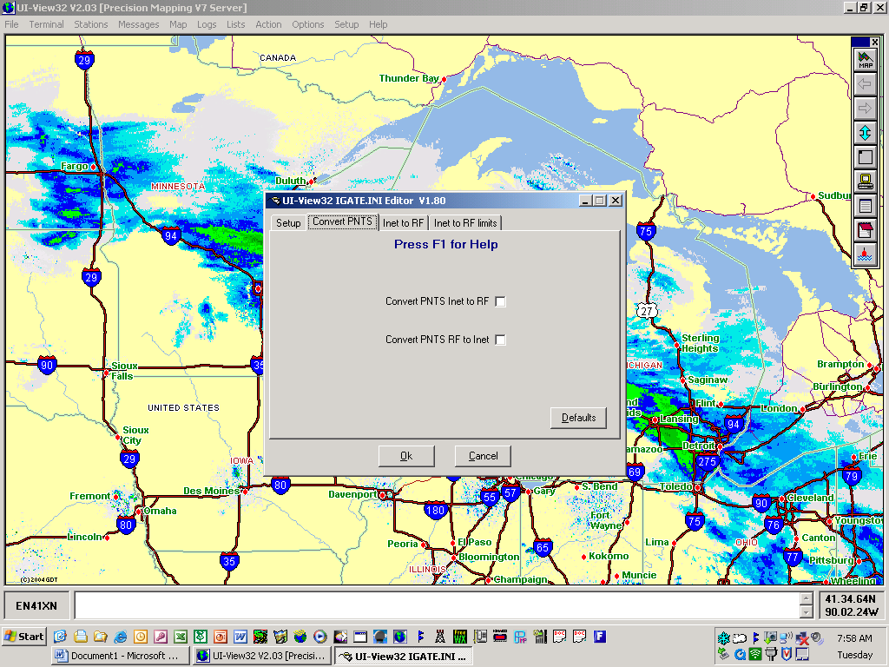

Leave all Blank (See Help File for more info).

4) Inet to RF Tab:

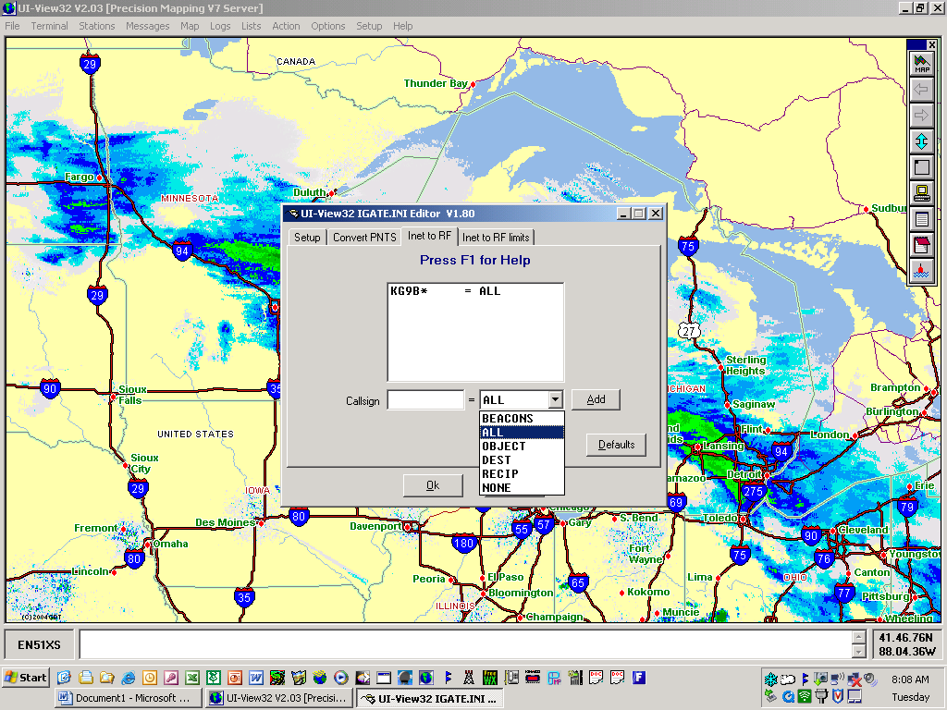

Enter Call sign in “Callsign” Box (Ex. KG9B* or KG9B-8) - Use the “*” as a wild card to pass ALL Traffic on that Call sign.

Next select from the Drop Down box (one to the right of the Callsign Box) - “ALL” will pass Beacons, Objects, Messages, and most everything (See Help files for more info);
Next Click “Add” button to add it up above. (NOTE: to Delete a station, highlight it in the list and hit delete on the keyboard; with more than 1 callsign on the list, the order of the Callsign is Significant Read the “NOTE” in the Help Files.

5) Inet to RF Limits Tab:

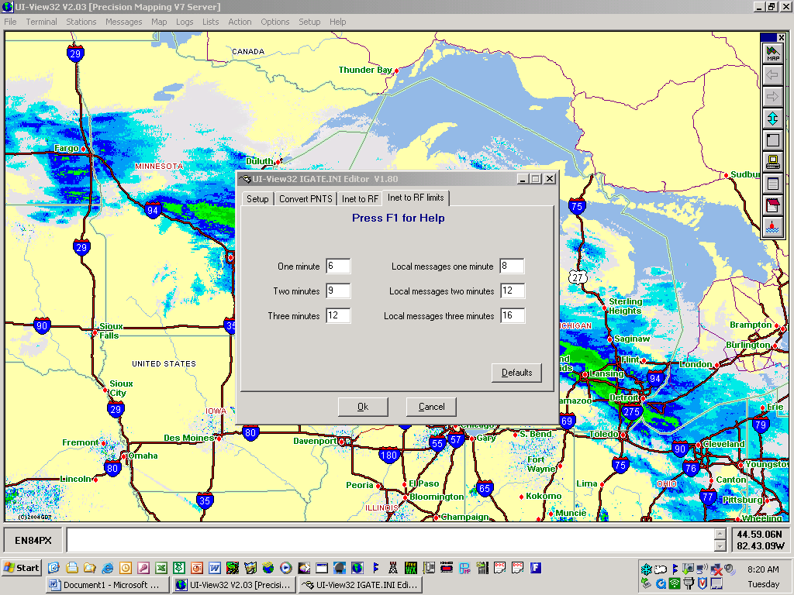

Here are the settings I use, Read the short Help files and set the setting you would like to use at your station.

6) From the Main Map Screen choose the “Setup” drop down menu;
then choose “APRS Server Setup” and check the 3 boxes in the “Gate Internet to RF” Section and then Click OK.

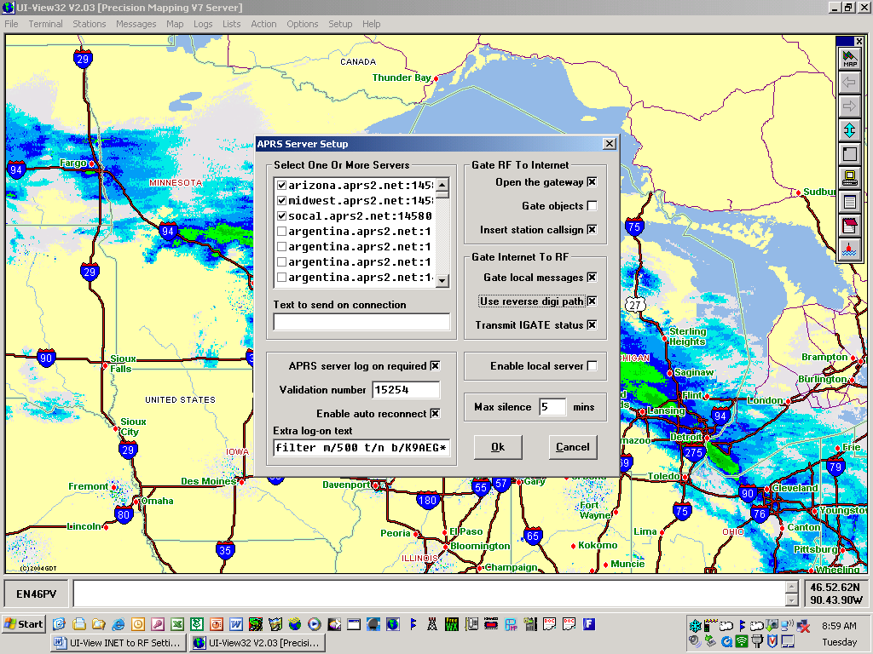

7) Then you have to have the “APRS SERVER CONNECTED” under the “ACTION” tab

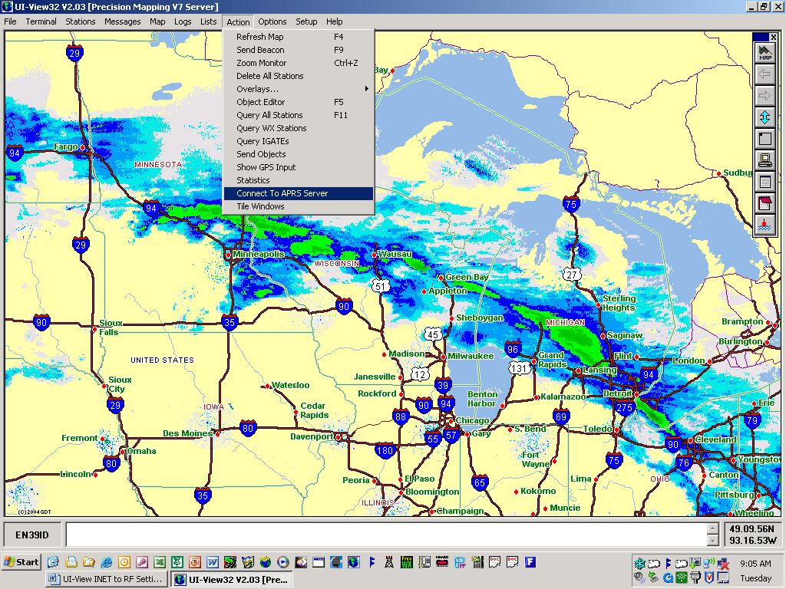

Gating Stations from RF to the Internet

In addition to the above settings to gate stations from the internet stream to RF, you can also gate stations that you receive on RF back to the internet stream. To do that, go to the APRS Server Setup screen and check all three boxes (Open the gateway, Gate objects, and Insert station callsign) in the “Gate RF to Internet” area.

After that, you need to connect to the APRS Server.

